Info 6205 Assignment 2 Report

For the Two Unit Tests:

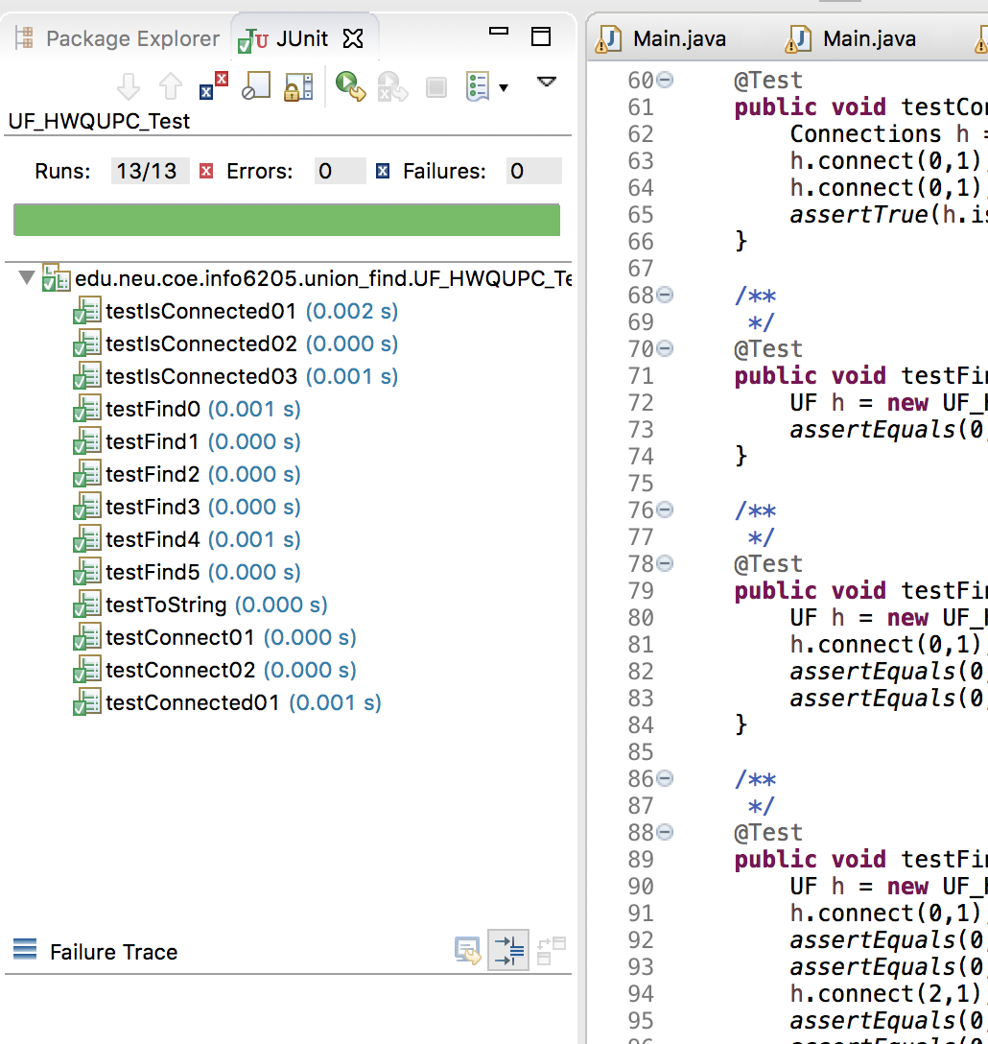

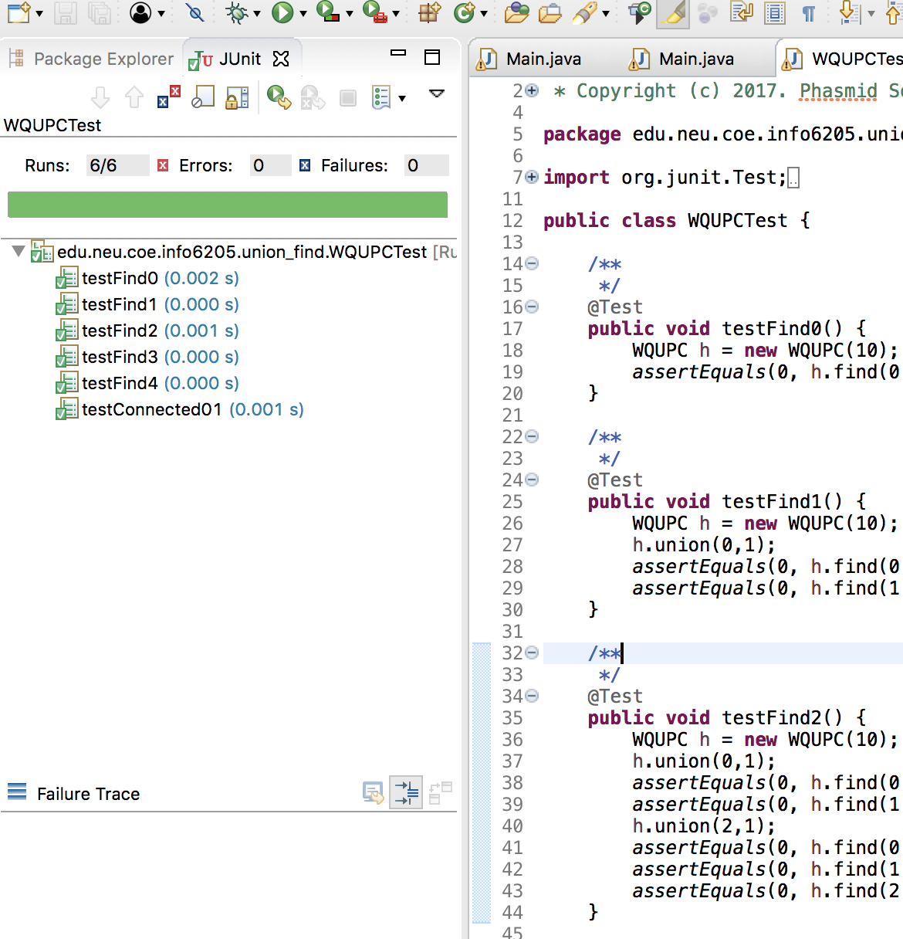

Screen shot for the Main Class:

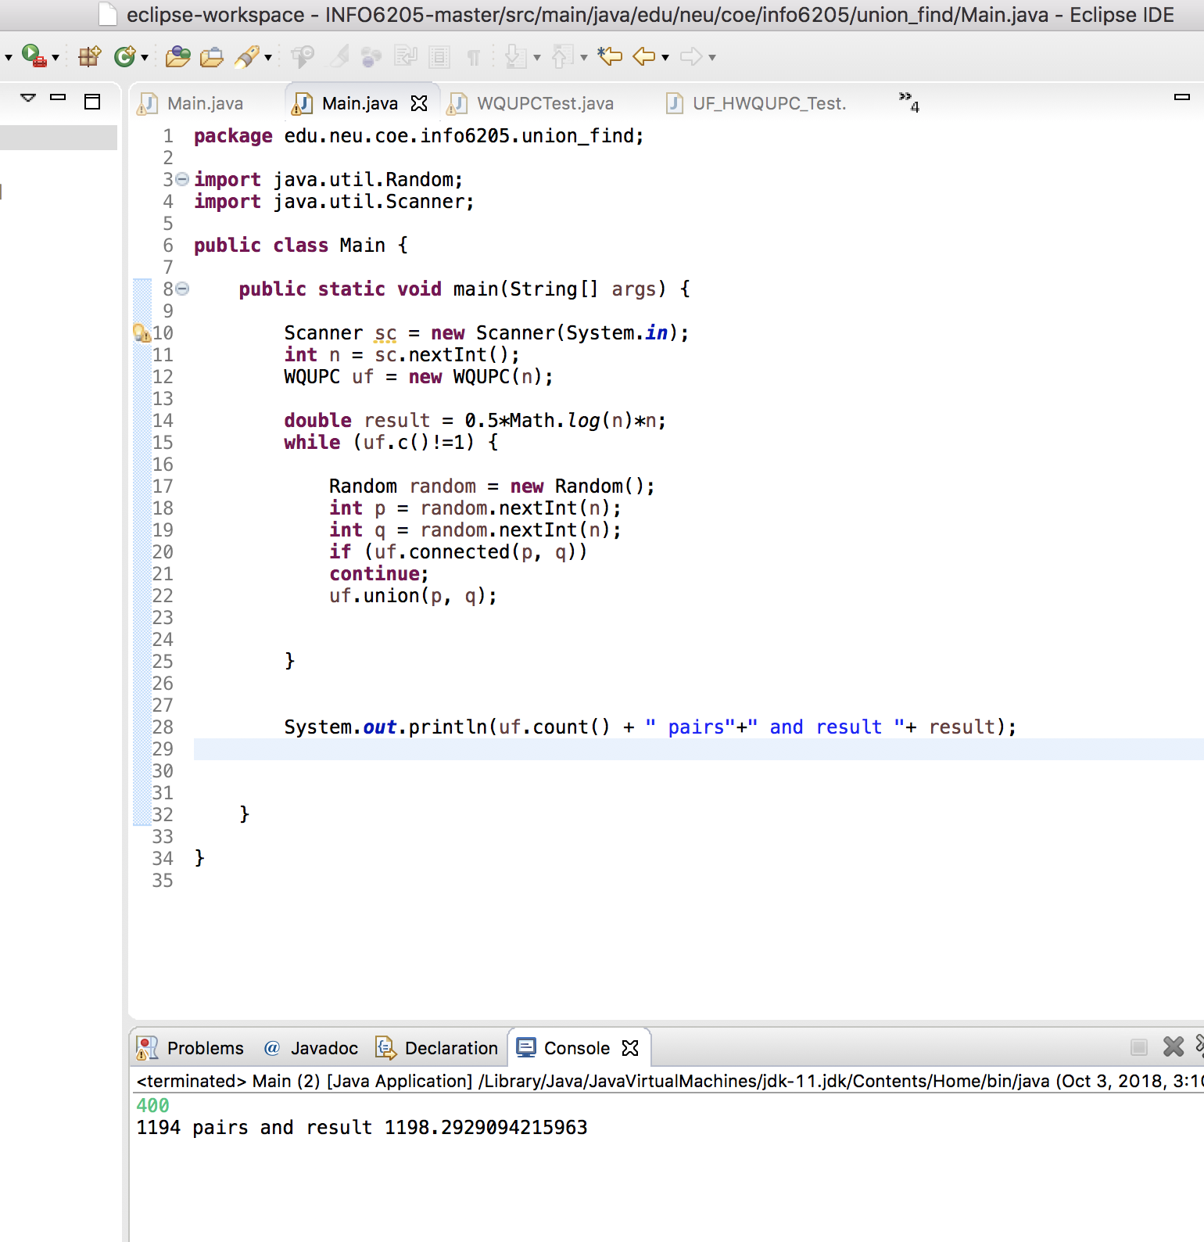

By the Test, we can conclude the hypothesis from this experiment.